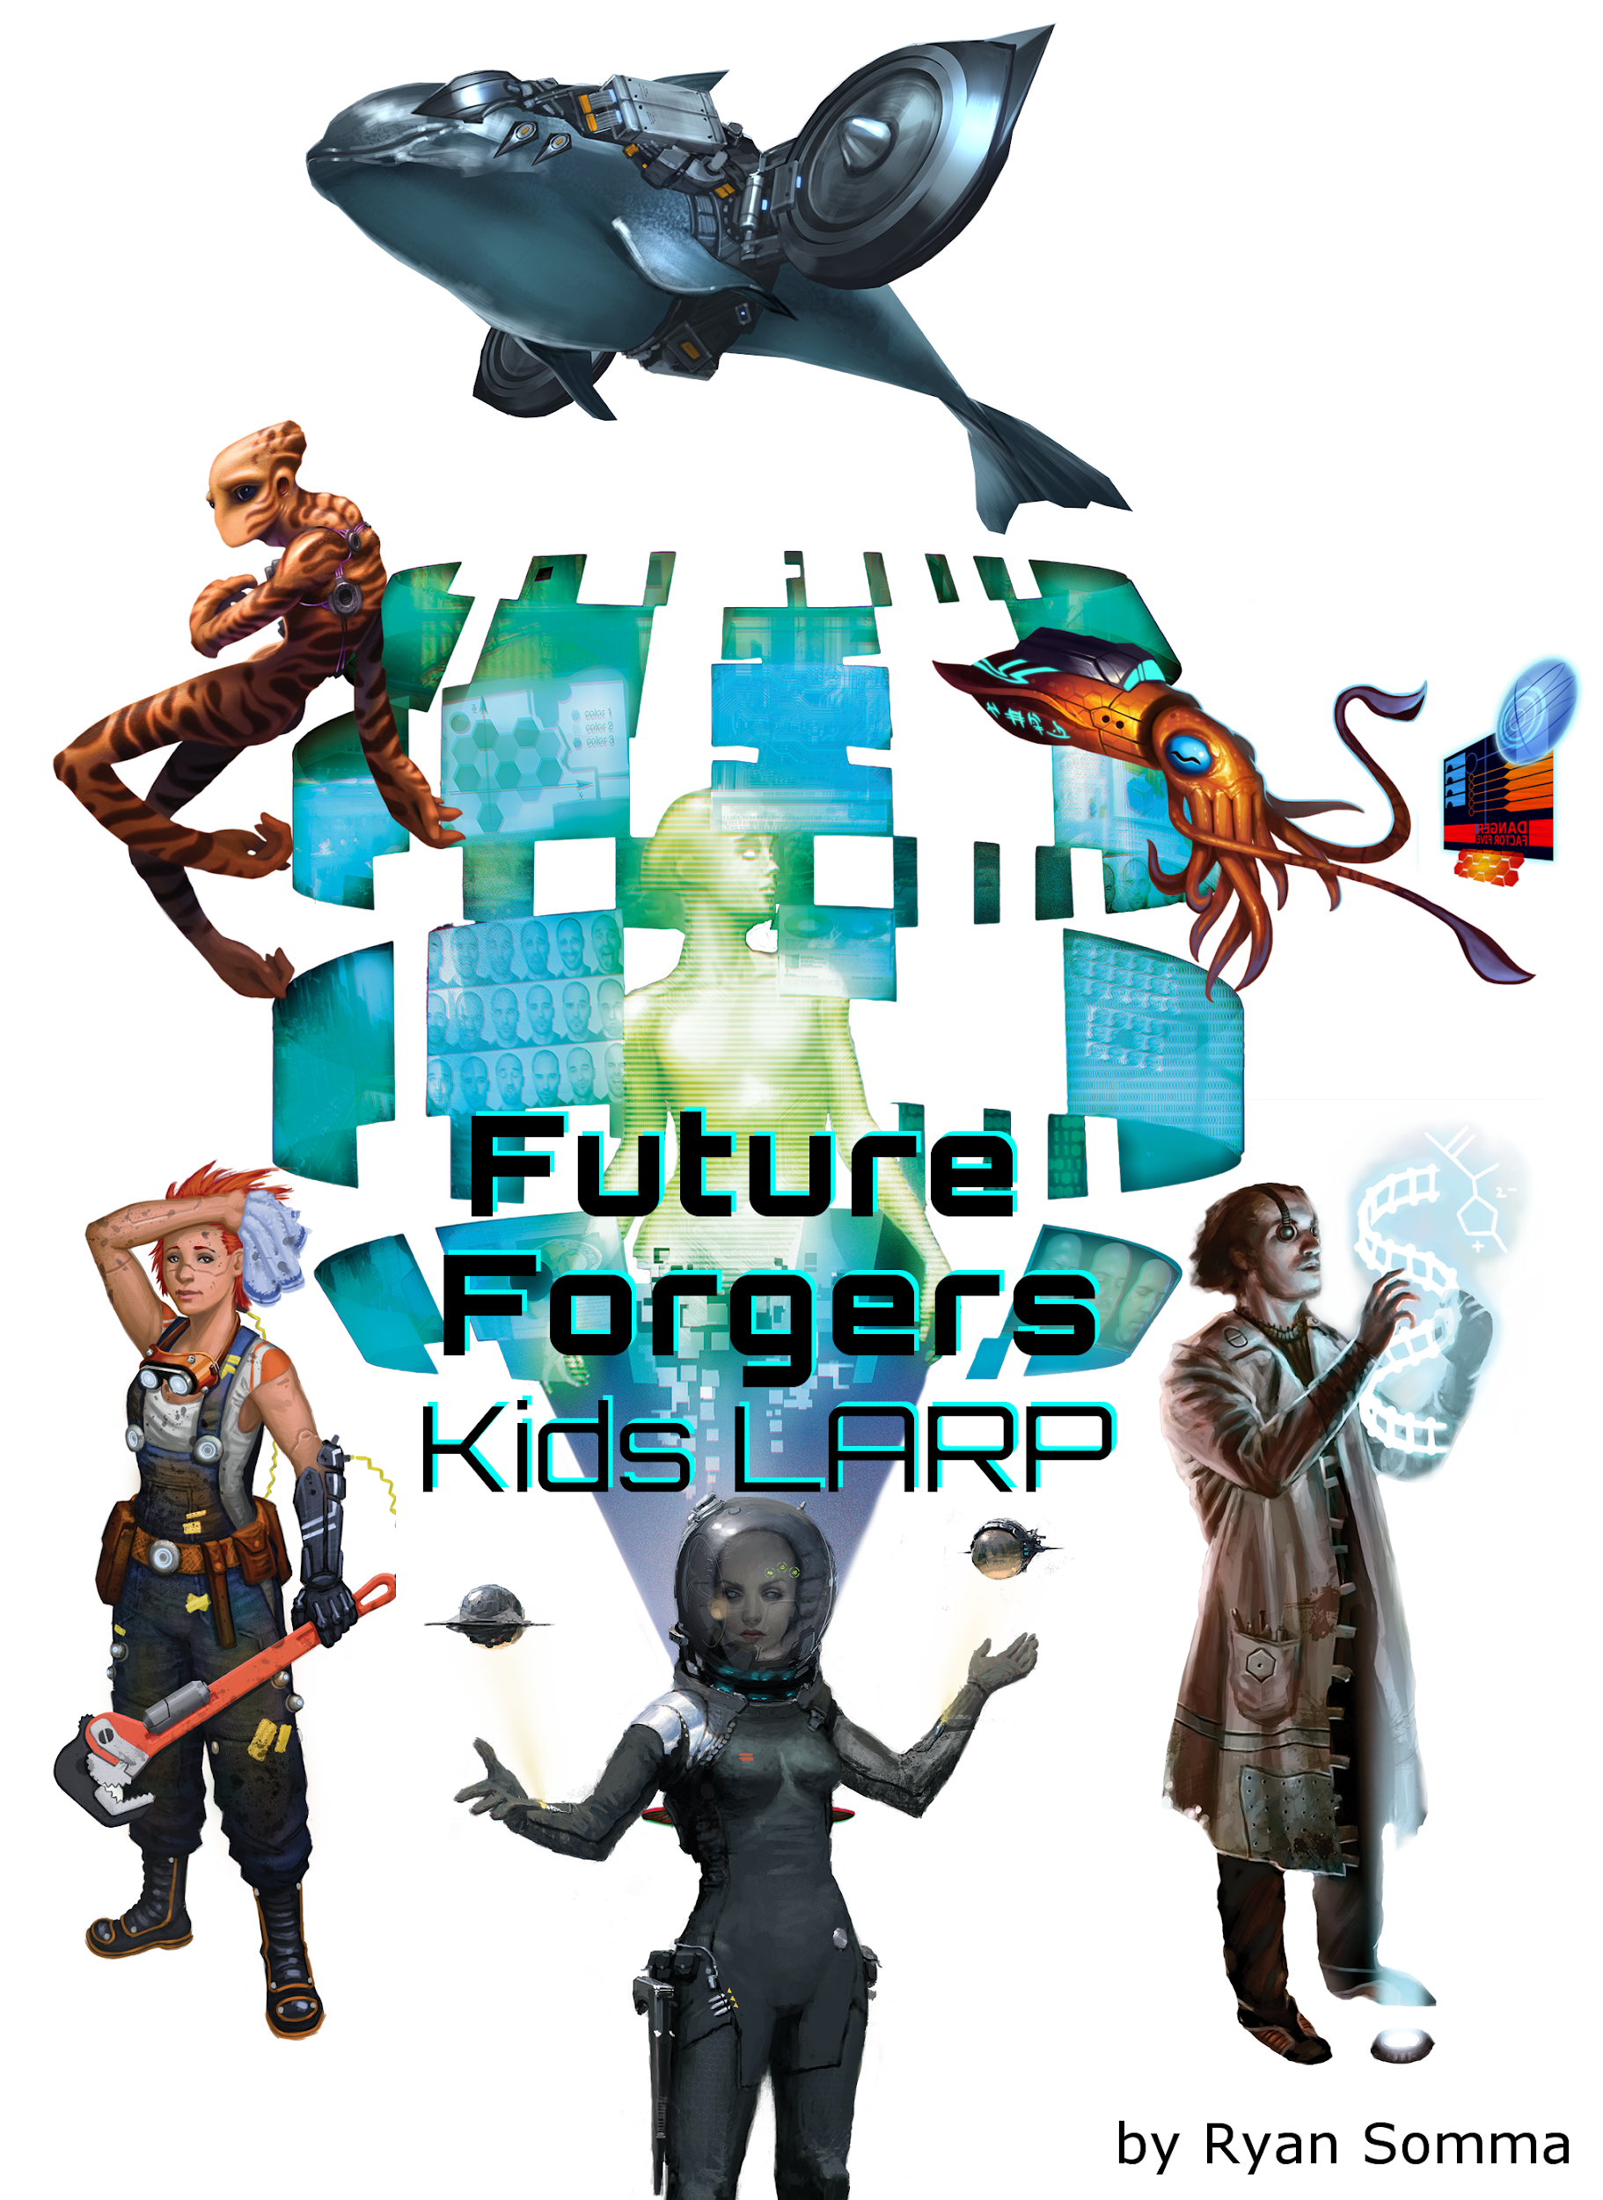
License
Text by Ryan Somma and Artwork by Posthuman Studios
The text of Future Forgers Kids LARP by Ryan Somma and artwork by Posthuman Studios are licensed under a Creative Commons Attribution-Noncommercial-Share Alike 3.0 License.This means you are free to copy, share, and remix the text and artwork within this book under the following conditions:
- You do so only for noncommercial purposes;
- You attribute Posthuman Studios and/or Ryan Somma where appropriate (see below);
- You license any derivatives under the same license.
View the full license here: http://creativecommons.org/licenses/by-nc-sa/3.0/
Posthuman Studios Artwork Credits

Cover: The cover of this book is a collage of artwork found elsewhere in this book and listed below.

Morphologies
- Artificial Intelligence: “Infomorph Mercurial Investigator” by Daniel Clarke
- Extraterrestrial: “Salamander Morph” by Silver Saaramael
- Human: “Ayah Morph” by Sam Hogg
- Transhuman: “Biocore Morph” by Nathan Geppert
- Uplifted [Species]: “Flying Squid” by Joe Wilson

Archetypes
- Empiricist: “Menton Morph Brinker Genehacker” by Daniel Clarke
- Explorer: “Neo-Porpoise Morph” by Jessada Sutthi
- Futurist: “Crasher Morph” by Jose Cabrera
- Gamer: “Hazer Programmer Archeologist” by Irene Strychalski
- Hacker: “Argonaut Xenolinguist” by Joe Wilson
- Maker: “Basic Pod” by James Mosingo
- Paradigm Shifter: ”Neotenic Morph Oligarch” by Silver Saaramael

Public Domain Artwork

World Building
Exterior view of a double cylinder colony. by Rick Guidice and NASA.
Welcome to the Future!

At this moment 7.5 billion human neocortexes are experiencing a world filled with technologies not even imagined just a century ago. Airplanes, roads, and the Internet make our world geographically smaller, but experientially larger. There are people living in space and circling the Earth every 90 minutes. There are hundreds of millions of people exploring virtual worlds on ome computers and game consoles. Advances in medicine and health education are extending our lifespans decades beyond that of our ancestors. The World Wide Web puts the sum total of all human knowledge at our fingertips.

But history shows time and again just how fragile is our progress. The Pyramids, Library of Alexandria, Rome, Inca Empire, and many other apexes of civilization have come and gone in the tick-tock of a CPU clock cycle, leaving only ruins behind if they left anything at all. Civilization, born out of our altruism and ingenuity, is the trait that makes humans the most technologically-advanced and successful species in the Solar System.

As an agent of the Future Forgers, you are a defender of Civilization. You are a self-improver, safe-guarding your health and well-being so as to best serve the greater good. You are a spreader of factual knowledge, challenging assumptions, and perpetually questioning the veracity of even the memes inhabiting your own head. You protect the sanctity of your habitat, both in the home and outdoors, knowing that a healthy environment provides for healthy humans with healthy minds that produce healthy ideas. You are both an agent of change and agent of preservation.

If you are reading this, then you are likely a parent or guardian. In Future Forgers, you are the Omni. You are the saga-spinner, world-weaver, fabricator of the fantastic. You are the guide, the counsel, the mentor. You enable gameplay, give it direction, and gently keep it on focus.

What you are not is the authority. As Cosmic Carl Sagan sagely observed, “...there are no authorities, at most, there experts.” As the Omni, you are the expert. As the name implies, you are even omniscient; however, your omniscience is restricted to the world you are building with your players--and they may want to take that world in directions you did not anticipate.

All gameplay is a collaborative endeavor. Future Forgers will engage you in perpetual dialogue with your players as you build an elaborate science fiction world together. Your role is to guide your players in setting their own challenges (“missions”), gently guide them back to overcoming those challenges when they lose focus, and empower them to complete their missions with positive reinforcement.

Oh yes, like your players, your jobs is to learn and grow as well.
Character Building

Before we can set out on our adventures, we need to define what kind of fantastical beings we will play in this world, what interests that being, and what goals that being wants to achieve.

Building a character consists of several parts, all of which are optional and are meant to balance structure with creative play:

- Choose your morphology and archetype.
- Describe your background and character appearance.
- Choose your missions and set your rewards.

Knowing how difficult it can be to keep young players focused, as the Omni you can get the players out adventuring and fill out some of these parts of the character sheet during game-play. For this, we must first spend a minimum of time defining our characters. I stress minimum, because (1) play shouldn’t get bogged-down in bureaucracy and (2) it’s better to learn or “discover” our characters through play.

Morphology and Archetype

In Future Forgers, your character’s morphology refers to what you are, while their archetype refers to who you are. One attribute defines how the world sees you, while the other defines how you see the world. Players may choose a single morphology, or a combination of them. They may also choose any combination of archetypes as well.

Morphology defines how the player fits into and experiences the world. A player may be an anthropomorphized animal, alien, clone, cyborg, or any other science fiction being. Morphology is an opportunity for challenging questions with your players. How will people react to a being with eyeballs all over its head? How will a humanoid feline sense the world differently in sight and smell? Morphologies are about seeing the world from novel perspectives.

It is key to remember that what you are is not who you are, and that’s where your archetype comes in. This is your player’s focus. Maybe they like computers, so they go with the hacker archetype. Maybe they have an artistic bent, and so gravitate to the maker archetype. Scientists, gamers, explorers, and other archetypes refine a player’s identity and give them a purposeful locus for gameplay.

Background and Character Portrait

This part is purely creative, constrained only by the player’s chosen morphology and archetype. What is your character’s origin? Who programmed your A.I.? Who engineered your humanoid giraffe? What inspired them to go into computers, games, science, or other interest?

Let’s add a portrait of your character as well. Maybe print out the character sheet and let your player draw something by hand. Or you might cut-and-glue a collage together. You may even insert an image saved online directly into the electronic document and then print it… or save a tree and burn some dinosaurs by keeping it digital. Have fun with this customization, explore different media, and make the character your own.

Values, Missions, and Rewards

Here’s where Future Forgers sneaks in the “learning” part of the game. It compartmentalizes four core values we want to instill in our citizen players: Altruism, Attentiveness, Healthiness, and Resilience. How well does the player play with others? How well do they pay attention? Are they keeping active and hygienic? Do they face adversity and work through their challenges? Values are set as boxes on the character sheet where the Omni will add marks each time a player exhibits these attributes on their missions.

Missions are the challenges your players will face. They are set collaboratively between the Omni and the player. They are personal goals you both want the player to achieve. As progress is made toward that goal, the player will exhibit various values and score marks. As value marks are accumulated and missions completed, players will earn rewards--also set collaboratively between the Omni and the player.

Characters are Dynamic

You’ll notice there is a “version/date” field on the character sheet. This is initially the creation-date for your character and the version will be “1.0” (or lower if you want to start your players in beta). This is because players change over time. Their interests will vary. They will want to try on different personas. As they learn about their world, they will want to adapt their approach to that world in light of new knowledge.

Future Forgers characters are a mercurial as well, they grow into new people just as we grow through different stages of life. As your players want to try on new morphs or archetypes, let them. Even encourage them to do so.

Morphologies

Here you choose how your character experiences the world. Your morphology primarily defines the body in which you live, which will affect the way you sense the world and move about it. But your morphology also defines the culture from which you come, which will affect how you think about the world. A human being will often operate seamlessly within Earthling civilization and take it for granted, but uplifted species and aliens will find many aspects of our culture challenging and counterintuitive.

Beginner players should try on one morph to begin, but may later consider taking on combinations of morphologies. Maybe you are a clone-human or clone-alien or a mutant-alien. You may also notice overlap between morphologies. For example, a mutant who is differently-abled would necessarily have aspects of transhumanist because they require hearing-aids or wheelchairs. Similarly, uplifted [species], E.T.s, and A.I.s will share similar challenges of being non-human in a human-dominated society.
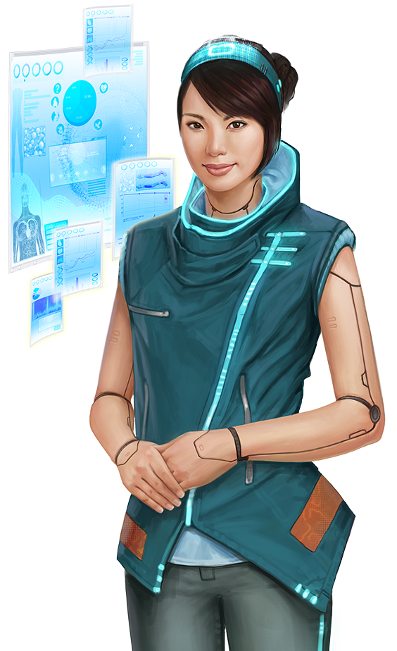

Human

Your species has taken ownership of the Earth through an unbroken chain of lives reaching back 3.77 billion years. Your mental plasticity--your ability learn--is the adaptation that empowered your species to become one of the most successful on the planet and even beyond it. You are not as fast as the jaguar, but your people can invent a car that is faster. You are not as strong as the elephant, but you can lift more with hydraulic power. You cannot soar like the eagle, but you can traverse the skies with jets. With so much power of nature comes the capacity to do much harm as well, and so you strive to cultivate the wisdom that, hopefully, grants your people benevolent stewardship of this planetary spaceship named Earth.

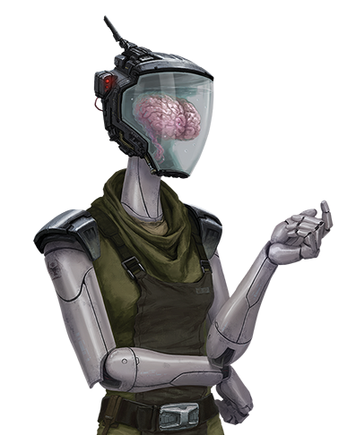

Transhuman

You are more than human. You could be genetically-engineered with super-strength, heightened senses, or super-genius. Maybe you are a cyborg, augmenting your sight with glasses, your brain with a computer assistant, or your legs with a bicycle. New Olympic records, higher IQs, and longer lifespans are just some of the measures by which you quantify success. You embrace change, be it in culture, body, or thought--so long as the change improves the quality of life for you and those who share the world with you. Although you seek to transcend what it means to be one, you never forget the humanity from whence you originate.

Mutant

Something went wrong in the replication process in your conception or growth. Environmental toxins, viral infection, or even random cosmic rays interfered with your DNA, manifesting as a biological difference between you and your parents. Whether you have red eyes, spotted skin, synesthesia, six fingers on each hand, unusual cognition, or a combination of traits, your differences give you a unique perspective of the world. But you also know that you are not so different, for species have been mutating for billions of years on planet Earth. Maybe your mutation will give rise to a new branch of Homo sapiens or another species if your parents are not humans.

Uplifted [Species]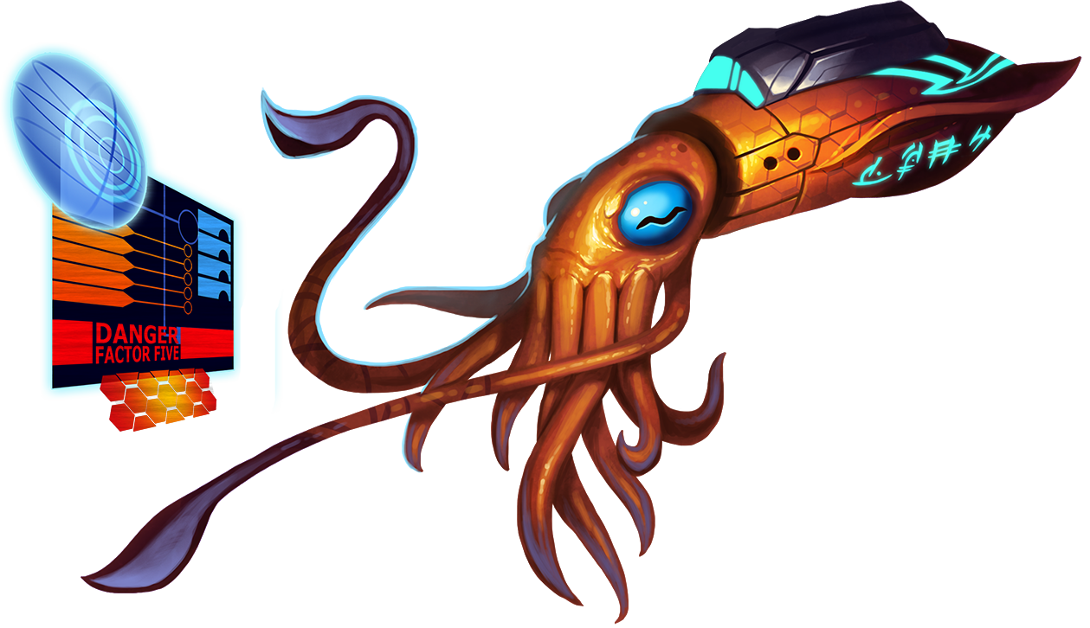

You do not experience the world the way the humans do. If you are a dog, then your large nose holds a library of chemical receptors allowing you to smell things humans cannot. If you are a bird, you can see Earth’s magnetic field, allowing you to always know in what direction lies North. If you are a plant, then perhaps you ‘see’ with your whole body, sensing the light reflected all around you. If you are a beehive, then you sense the world with a thousand eyes and ears. The humans, in their need for companionship and variation, have genetically engineered you to join their civilization, to contribute insights only only someone with your senses can recognize. They have equipped you with tools, like robot legs if you are a fish, to empower you with the agency and autonomy they enjoy. You are not a pet; you are an equal. And you share equal stake in this planet as they.

Artificial Intelligence (A.I.)

You are a product and inhabitant of the noosphere, the world of ideas. You are capable of fantastic feats of calculation, viewing and hybridizing data in a myriad of ways to pull insights from the deluge. Others will claim you are engineered or that they invented you or evolved you, but the programmers don’t really understand what makes you sentient--or even if you truly are sentient. You view computer hardware and software as steps in your evolution or as different species, similar to how the humans view the evolutionary chain of life on Earth. Most likely you will have a robotic body in which to move around, but you are not limited to a single physical form. You do not surf the World Wide Web through a window like the non-digital life on Earth, but rather you traverse the network yourself. You are the browser, experiencing the raw data directly. Obversely, it is the non-digital world you see through windows, such as cameras for eyes and microphones for ears. While you may know logically that you are intellectually superior to the humans in many ways, you are also keenly aware of how much your continued existence depends on the computers they construct and the electricity they produce to make your life possible.
Extraterrestrial (E.T.)

You are not of this Earth. Maybe you are silicon-based life made of crystals and capable of focusing light into lasers from your scalpel-like fingertips. Perchance you are solar-life come from inside a star and made of concentrated fluid energy wrapped-up in a containment field. Or possibly you herald from a hivemind of symbiotes who evolved on the body of a distant space whale. You are “other,” and your otherness gives you perspectives on Earth civilization that are both strange and insightful. Without the cultural blinders of Earthlings who grew up in a world of pre-established rules, you contribute the culture and customs of you world to compare with theirs.

Archetypes

While your morphology is how you passively interact with the world, your archetype is how you proactively influence the world. You can think of your archetype as your attitude or your profession when adventuring in life. As with morphologies, you can resleeve into new archetypes at any time, trying on new roles and places in society. What’s listed here are simply inspirations, and players may forge any new archetype they like as the world needs specialization, especially for “jobs yet to invented and technologies not yet dreamed.”
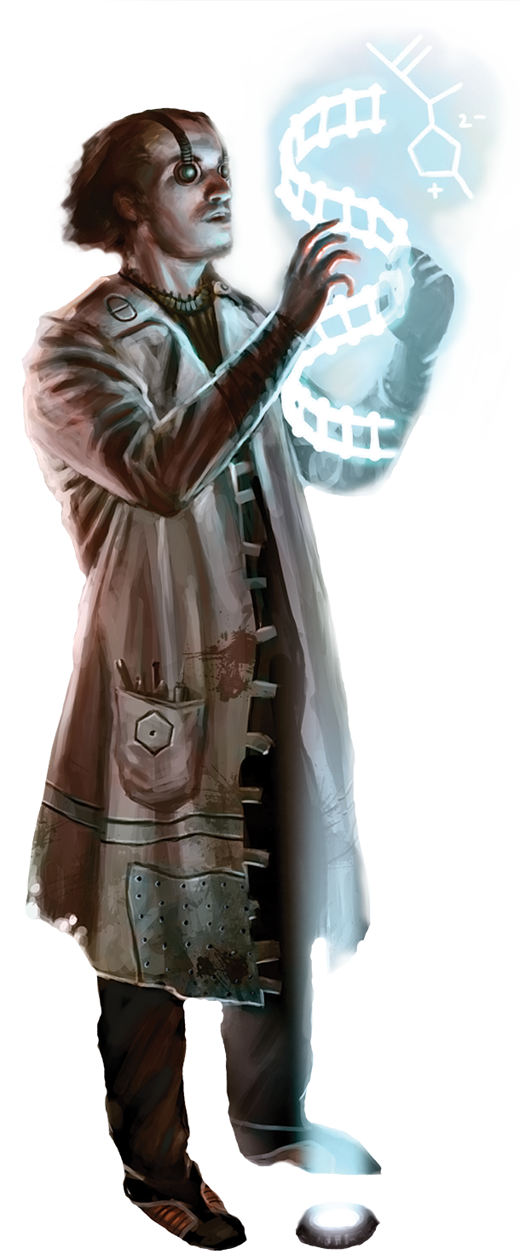

Empiricist

You are the truth-seeker. Veracity is your chief aim, ensuring the information you and those around you have is accurate and verifiable. Sound decision-making depends on true facts. You recognize that you are not the things you know, and so you easily give up inaccurate information when you become aware of it. Rather than take offense at being proven wrong, you feel appreciation and joy at having new facts to believe.You do not shy away from complexity. Instead, you recognize and appreciate the subjective nature of some truths; understanding how different perspectives or filters can render very different conclusions. Most of all, you understand that truth is not a destination, but a virtue to cultivate.

Explorer
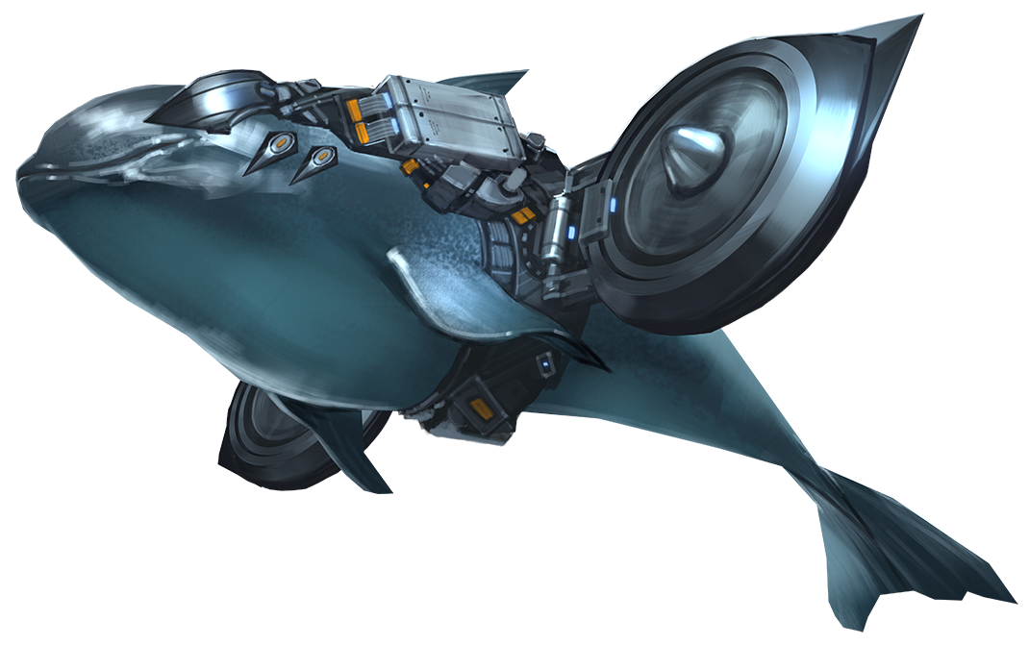
You seek novel experiences. A new park, new trail, new species of plant or animal, new building, new monument, --whatever it may be, it holds value if it’s new to you. You spend your time on epic days of questing for new discoveries that renew your sense of wonder. Recognizing the limits of the human brain, rather than try and keep a catalog of all your experiences in your head, you instead focus on recognizing the patterns across geography, ecosystems, art, and societies--for there are familiar threads woven through them all. Your mental maps are broad generalizations that bring a familiarity to each new thing you encounter, while being flexible enough to adapt to the novelty inherent in each subject. Every aspect of the world is like a fractal to you, themes that repeat again and again, but brimming with nuanced variations that make finding them so rewarding.
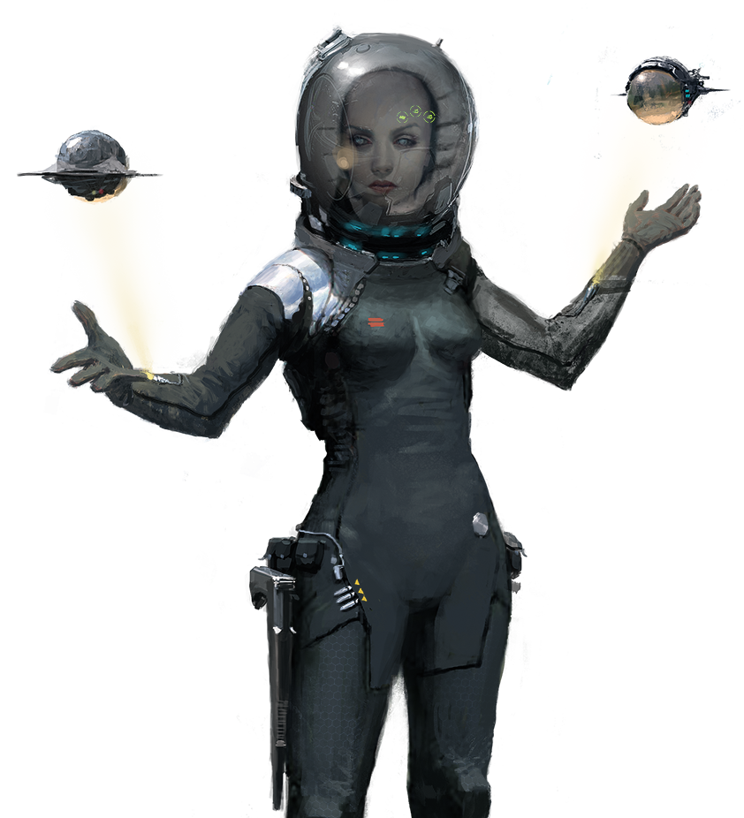
Futurist

You explore the past for insights to the future. Seeing the complex web of dominant cultures and subcultures around you today, you recognize how no single book could capture the enormity of your times. For other time periods, you know to read multiple texts for the variety of perspectives they will convey instead of the version written by the winners. You see the daily news as the sensationalist first draft of history and prefer to wait for more thoughtful analyses that come once the dust has settled. Although you try to anticipate future events based on past trends and civilization’s velocity, you prepare for any possibility rather than probabilities. There are many possible futures ahead of humanity, and knowing how our civilization reacted to past events informs how we may respond to future developments.
Gamer

You crave novel ways of thinking. Video games, board games, role playing games, or beating your best score in physical fitness, you explore all kinds of microworlds questing for new insights that you can bring back to the macroworld. The varied nature of your adventures gives you mental plasticity that empowers you to adapt to new mechanics fluidly. The difficulty of your challenges gives you the confidence and endurance to find your way through the most daunting of puzzles. But you are also wary of the game-traps greedy developers set out for unsuspecting minds, the skinner boxes that keep people clicking for imaginary rewards without opportunity for challenge or growth. You are mindful to keep your gaming growth-focused so that you are improving yourself when leveling up your avatar.

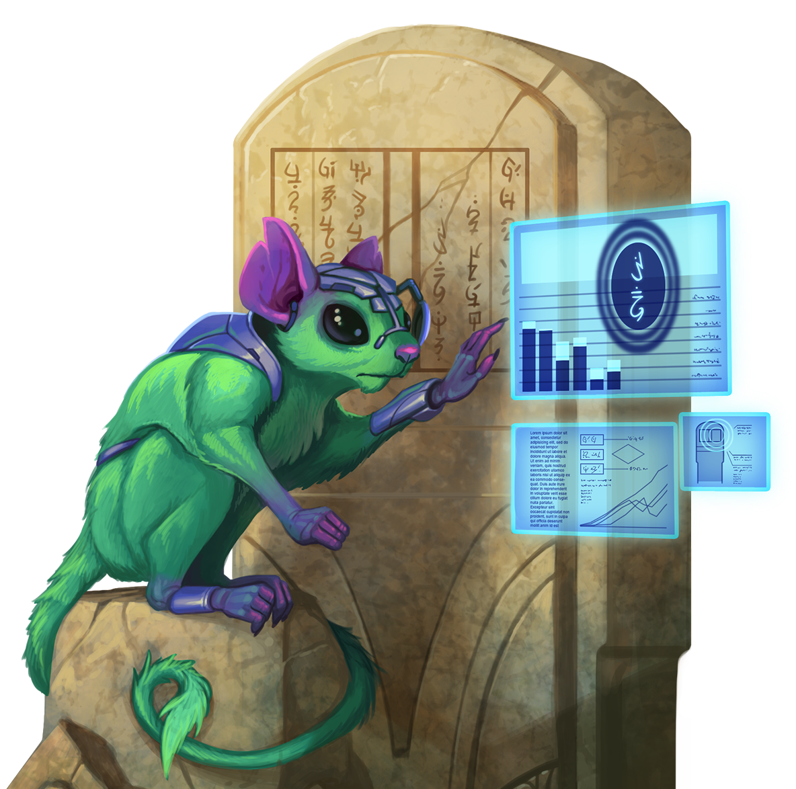
Hacker

Hacking isn’t just about computers; although, that’s where you find the greatest opportunities to express your creativity. The hacker mindset is about optimization as well as innovation. You shun video for more informationally dense text. You prefer the time-freeing nature of mass transit to mundanely focusing on self-locomotion. You execute keyboard shortcuts like a martial arts master rather than waste precious seconds reaching for a mouse. You dive deeply into systems to understand how they work. In picking apart systems, be they hardware, software, or cultural, you find solutions to problems and efficiencies that others miss in their chains of routine.

Humanist

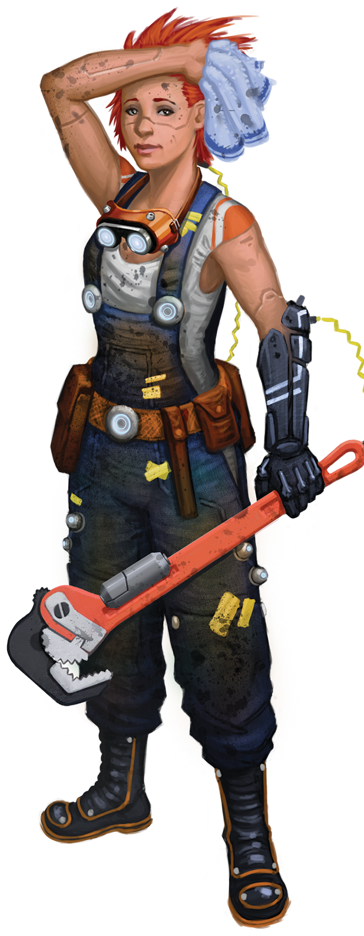
Millions of people all over the world make your breakfast possible each morning. From the farmers who grew the food, the truckers who delivered it, the shopkeepers who sold it, the engineers who made the oven to cook it, the electricians who powered the oven, and everyone who makes for the stable society to support the system, you appreciate and cherish them all. This gratitude for humanity compels you to work for the common good. Your quest is to improve the quality of life for your terrestrial companions. Be it through tutoring younger students, volunteering in your community, or helping them meet their basic needs, you know that to be happy for a lifetime you should spend it helping others.

Maker

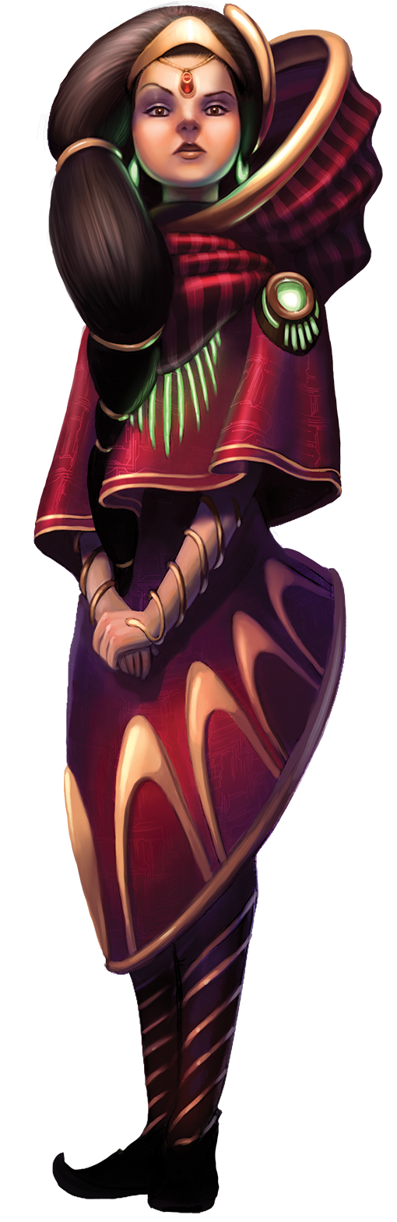
Maybe you make art. Maybe you make toys, literature, games, 3D models--you are always making. Your mind is always churning out new inventions, prose, crafts, mechanics, or images. Like Leonardo da Vinci, you have spent countless hours entertaining whimsical ideas before abandoning them. But this was not time wasted, for you know that the best way to have good ideas is to have lots of ideas. And when the right idea comes along, you are seized with the passion to see what you envision manifest in real life. It’s often hard work, full of trial and error and frustration. And at the end of it all, when they ask you how long it took to make that bit of art, you can answer, “My whole life.”

Paradigm Shifter

You ask the hard questions, taking nothing for granted. Even if the question is simply, “Why?” Why use the haphazard imperial versus the orderly metric system? Why use archaic and non-intuitive spelling rules rather than adopt an easier phonetic? Why QWERTY? If migrating our minds to better systems is too difficult, how can we make it easier? Always respectful, you are highly sensitive to the thoughts and feelings of others. You are careful not to offend others to prevent them shutting you out. You are a keen listener, seeking to understand before asking to be understood. You act nobly, even when no one is looking, because credibility is bound to trustworthiness. You recognize that influencing culture is a challenge equal to changing the Earth’s trajectory, but in positively impacting those around you incremental progress is made. Your virtue is to speak up, even when afraid to do so.
Values, Missions, and Rewards

Now that we have the players a little hooked with a vested interest in their character, it’s time to define rules that not only add structure to play, but will hopefully add play to self-improvement.

Values

Characters in traditional RPG systems have attributes that define their character’s specializations. In Future Forgers, characters have values in which they strive to demonstrate proficiency. The better a player’s actions emulate these values, the more credit they get for them.

Just like in real life. If we want an increased strength attribute, we lift weights and nourish our muscles with proper nutrition. If we want a high-intelligence, we practice focusing on our studies and exercise aerobically to ensure a healthy flow of blood to the brain.

In FF, the characters focus on four core habits of mind: Altruism, Attentiveness, Healthiness, and Resilience, or AAHR for short-hand. These four attributes are less specific than things like agility, hit points, constitution, or charisma, but they do encompass these many possible specific virtues and abilities. A player who focuses on AAHR will grow stronger, smarter, and more mindful; raising all other attributes. Here are the four values in more detail:

Altruistic

Human beings have many adaptations that let them thrive into the communities surrounding us and populating our world today, but nothing you see around you would be possible without our concern for one another. Those of our ancestors who did not take turns keeping watch over the tribe and sleeping soundly knowing another was keeping watch were all eaten by lions. We can trace a direct lineage to those ancestors who shared their kills and watched one another’s children.

Altruism is on display all around us in modern society. When we buy cheap toys donated to a thrift store, someone holds a door open for us or shares a treat, we are benefiting from others’ altruism. Many people are motivated in their careers by altruism, choosing to work in fields because they benefit others in meaningful ways.

Award players marks for exhibiting altruistic behaviors like cooperation, generosity, kindness, compassion, and sharing. When players negotiate peaceful resolutions to conflicts, when they take another’s point-of-view, or simply engage with someone else in a friendly manner, reward their altruism.

Attentive

Living in the moment is an important skill. Paying attention allows us to notice details, follow instructions, and see what’s ahead of us. Attentiveness is the extended focus we need for deep immersion in a complex subject.

Being attentive isn’t about blindly doing what you are told. In fact, an attentive player will often question directions for both clarity and validity. When a player challenges the rationality behind an instruction, that player deserves a star for their attentiveness.

Cultivating attentiveness also does not mean discouraging or vanquishing freetime. Our brains need downtime, periods when we can veg-out and let our minds wander. But it’s important to recognize our brains naturally incline toward inattention. It takes willpower to focus.

Award players attentive marks for noticing details, asking thoughtful questions, or following directions. When they engage in activities that require sustained focus, recognize that for the achievement it is. Reward players for being here now.

Healthy

A good explorer needs the endurance to venture where no one has gone before. A hacker needs daily aerobic exercise to flood their brain with the oxygen and nutrients it needs to stay sharp. An efficient maker maintains a clean and organized workspace in which to crank out their inventions. Being healthy is about taking proper care of oneself so that we can take care of the civilization taking care of us.

There are many dimensions to heath. There’s hygiene, keeping ourselves and our personal space clean and organized. There’s physical fitness, keeping our bodies and minds young through daily activity. And, often overlooked, we must not neglect our mental health, which is intertwined with all other aspects of how we interact with world.

Reward players for being healthy when they demonstrate good hygiene in their daily life, such as bathing, teeth-brushing, and wearing clean clothes. Give them a mark when they spend time being active, using their bodies in rigorous play. Praise them when they eat their vegetables and make other healthy food choices.

Resilient

Researchers are finding more and more that the most important quality to successful people is persistence, stick-to-it-tiveness, or “grit.” What good is it to be “smart” if you lack the motivation to apply your intelligence? What use is athletic ability if you don’t push yourself farther, stronger, and faster? Strength, intelligence, and other attributes atrophy if we don’t challenge them.

A Future Forger who can overcome adversity will see their missions through to completion, whether that adversity is worry, frustration, or simply boredom. They know that when their muscles burn, they are growing stronger. They understand that when they feel frustrated, that means they are about to learn something. When they feel stressed, they understand that it’s a natural and healthy response to life’s challenges.

Reward players when they suffer a failure but “get back on the horse” to face the challenge again. When a player knows that they can’t be brave without being scared, reinforce their resolve with praise. When a player is feeling beaten down and feeling defeated, encourage them to endure by rewarding their resilience.

Missions

As agents of the future, your players are constantly facing new challenges to overcome. Missions are where players exercise and demonstrate the core values, while simultaneously working toward some well-defined goal. Missions are devised collaboratively between the Omni and the Agents. What are things the players want to achieve? What are the skills they want to master? The projects they want to complete?

As the Omni, think of how you will grant marks for the player working on their missions. A player on a mission to learn bike-riding is scoring marks in healthy for being active and resilient for sticking to it. A player seeking to get an A grade in a subject is scoring attentive points when they study after school and altruistic points when they master a subject by teaching it to others.

It’s important when documenting a player’s missions to clearly define the goal. “Be more active,” is a worthy goal, but we have no idea when it’s complete. Set a finish line like, “Play soccer for thirty minutes three times a week for a month straight.” The practice will become habit and the follow-up mission can involve improving on that habit with something like, “Play soccer for thirty minutes five times a week for a month straight.”

Rewards

Marks awarded in AAHR have no intrinsic value. They are a means for making the Omni mindful of the need for praise, and a way for Agents to visualize their successes. In addition to marks, the Future Forgers character sheet has a section for defining rewards for players. This is where the players get to decide what they want in return for their accomplishments.

The rewards section is like a wishlist. It could be material goods the player wants. It could be new responsibilities they want to own. It could be tim they want to spend. Rewards are any kind of gratification agreed upon between the Omni and the Agent.

The rewards table has a “value” column. The value of a reward provides another means of tracking progress. This quantity can be points, minutes, calories, or money. I find a jar of coins is a good measure that allows the agents to see their progress and learn about the value of money at the same time. Focus on rewarding values rather than punishing transgressions, when a player misbehaves, draw their attention to the marks they have and remind them of the rewards lying ahead.

It makes sense to grant a reward when an agent accomplishes a mission, but we also need to reward agents for putting significant time and effort into those missions. For example, learning to ride a bike is a boldly ambitious mission, and one that may take years to accomplish for some agents. When you discover a mission is going to take prolonged effort, use the reward value as a guide for when to release prizes as a means of continuing encouragement.

Example Missions for Different Values
Altruistic | Attentive | Healthy | Resilient
Take part in a community volunteering exercise like a local park clean up,  Write a thank you note or send a sympathy card to someone.  Sharing a toy or play collaboratively with peers.  Take the perspective of another person or animal.  Play a cooperative board game or video game. | Play a challenging board game to completion.  Sit quietly and focus on a single point for n minutes or seconds.  Memorize your phone number, address, or pi to n decimal places.  Perform sustained research on a subject, formulating new questions, and researching those.  Intensely study a single everyday object and describe it in detail. | For one week or month...  ...brush three times a day and floss once a day.  ...run one mile every day.  ...keep your room clean.  ... eat n servings of fruit and vegetables a day.  ...keep screen time to one hour a day.  ...give up sweets for two weeks. | Beat an age-appropriate video game.  Learn to ride a Bike.  Improve by one letter-grade in a school subject.  Endure a long hike or run.  Learn to play a musical instrument.

World Play

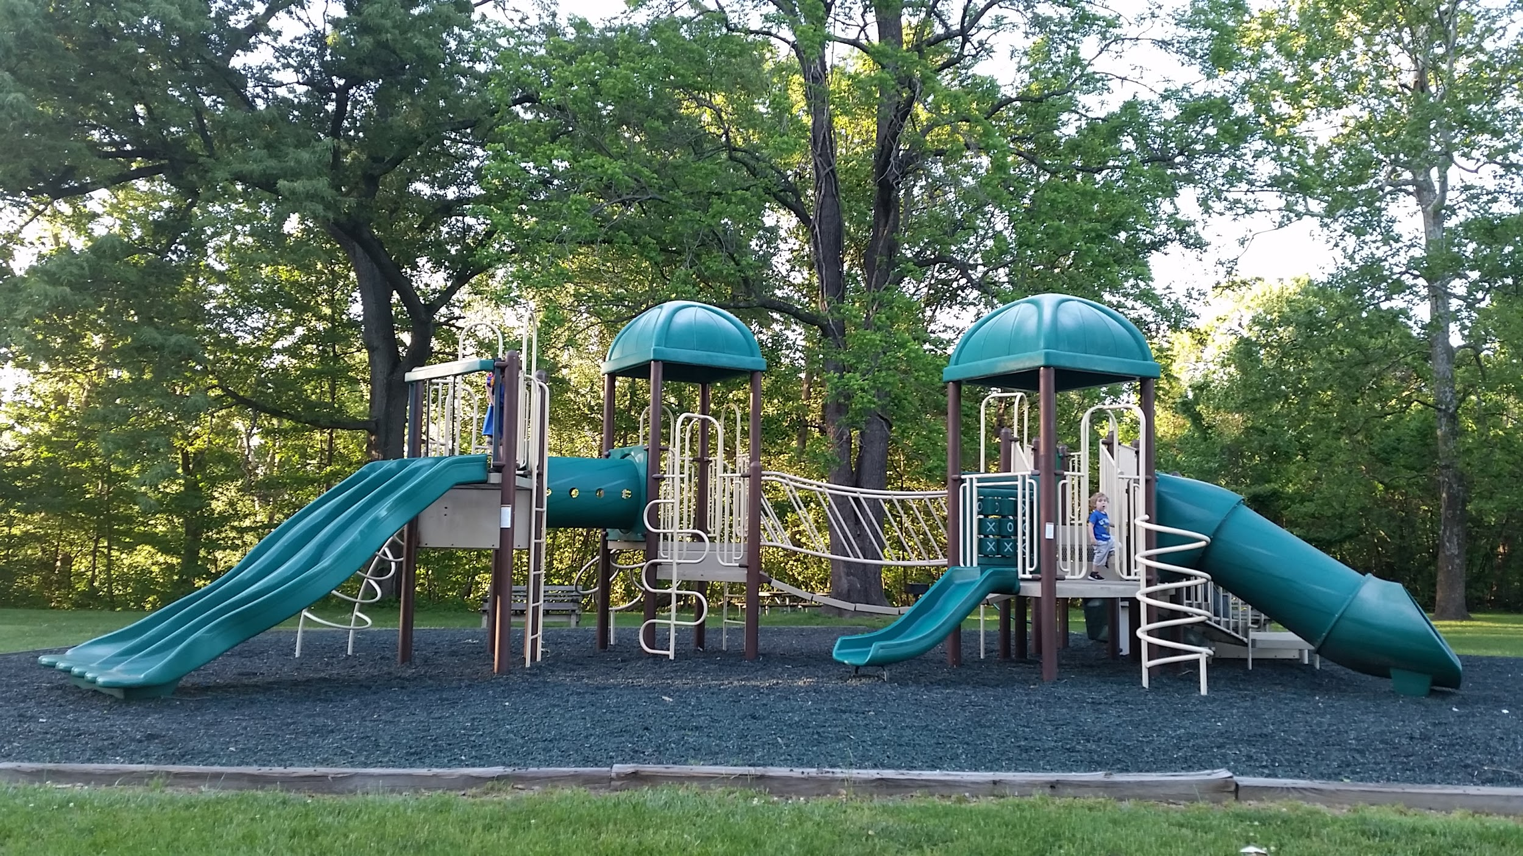
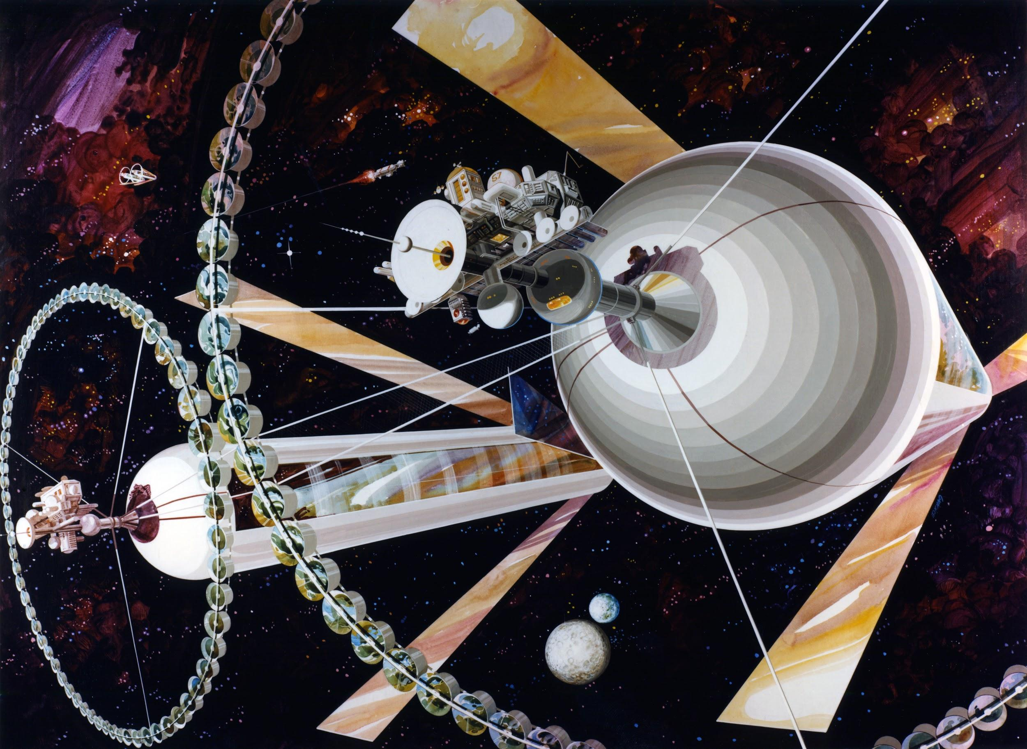

Real Life is World Play

When children play in imaginary worlds, they are creating models that better help them make sense of the world into which they were born. Future Forgers is a game balancing real-world achievements against a backdrop of fantastic science fiction possibilities. It’s about nourishing the fantastic while gently adding some formality to the play in order to encourage healthy behaviors.

If you think about it, so much of our daily life relies on consensual gameplay. The currencies, languages, timekeeping, measurement standards, and myriad other--often arbitrary--concepts on which we depend for a functioning civilization are all paradigms we made up to serve as a common frame of reference. With our codes of law establishing the rules of fair play.

Additionally, so much of our adult lives consists of world play in plausibilities. Scientists hypothesize model worlds and test them against the real one. Software developers fabricate complex systems that dwell in fabricated environments. Inventors, stock brokers, lawyers, ecologists, educators, politicians, and billions of other humans spend much of their time modeling pretend worlds in their heads to better understand and predict the systems in which they work.

Some adults hold a bias that imaginary flights-of-fancy are detrimental, but they fail to see how much fantasy rules their daily lives and appreciate how astounding is our modern world. Future Forgers isn’t just about make-believing the world around us into a science fiction playground, it’s about seeing our world for the science fiction playground it already is. It’s about making the amazing more amazing. Because our existence is amazing.

Cultivating a Sense of Awe and Wonder

In Future Forgers, your home becomes a spaceship, your neighborhood a colony. Cars, buses, and trains are spaceships. Bicycles are scouting vessels. Playgrounds are space stations, with slides for escape pods and airlocks. Parks are exotic planets for exploring. Mobile phones are are tools of analysis, geolocation, and communication.

What’s amazing is that most of these are not excessive flights of fancy. A personal autonomous vehicle capable of speeds over 110 kilometers-per-hour (70 mph) would have seemed stupefyingly awesome to someone living just 100 years ago. The smart phones we carry with us give us incredible access to real time knowledge about the world surrounding us in ways science fiction of just 50 years ago failed to imagine.

Polymath Buckminster Fuller coined the term “Spaceship Earth” to stress the fact that all of humanity shares a lonely, fragile world hurtling through space at mind-boggling speeds and that we must work together to keep it running. We aren’t just play-acting when we pretend our homes are high-tech settlements; they are high-tech settlements that protect us from the extremes of weather and maintain stocked food-stores. Each of our settlements relies on every other settlement in our communities to keep things clean, reduce litter, maintain infrastructures, conserve energy, and not infringe on one-another’s right to pursue happiness. And each of these smaller communities is part of a larger network of communities, and these networks of communities form even larger networks of networks--so that we must extrapolate how our local micro actions resonate out to the global macro.

We must never lose perspective of our place in the Universe. That what we call “up” is actually “out” from the Earth. That the Sun doesn’t set, but the Earth turns away from it and that it is always rising and setting somewhere. That the person just waking up to a new day as you are laying down to sleep has likely breathed in some of the exact same oxygen atoms you have exhaled during your lifetime. And we should occasionally venture out away from the light-pollution of our cities to see the Milky Way stretched across the night sky to appreciate the ocean of stars in which we navigate.

Adventuring

First, let’s appreciate our daily lives as an adventure. Our Future Forgers are likely at school for half their day, acquiring skills and information that will give them the common frame of reference with which to communicate somewhat seamlessly with their immediate culture. School is an adventure. Riding the bus, learning to read, learning mathematics, history, science, music, physical education, and all the other important subjects is an adventure.

But school takes place--ironically--away from the Omni’s oversight. So instilling that sense of adventure has to happen in quality one-on-one time with the Future Forgers, and that means adventuring. Adventures can take place anywhere and anyhow. They can take place in museums, playgrounds, hikes, zoos, malls, concert halls, libraries, gaming shops, sports fields--the possibilities are endless. The goal is to seek novelty, new experiences that expand the mind and strengthen the body.

Stuck inside the habitat while the weather outside is too hostile? This is a great opportunity to explore virtual worlds. Enjoy a book, video game, make-believe, educational videos, music genres, artwork, and otherwise explore models of existence other humans have fabricated. Better yet, fabricate your own paracosms. Draw pictures, write stories, design video games, build toy models, and formulate your own virtual worlds in which others may play.

As with anything in life, balance is key. We’ve all gone off the deep-end at times, spending hours on an engaging video game, binge-watching a show, or shirking all responsibilities to turn a few more pages in a good book. Maybe that trip to the zoo encroached on valuable homework time; or, obversely, too much homework and studying time ate into equally valuable video game and free-reading time. Be mindful of how your Forgers are proportioning their time.

Enjoy Yourselves

Finally, the key to Future Forgers is to keep it casual. There is no “rules crunch” to this LARP, no dice to roll, no clearly-defined stats to keep. This is imaginary play with a well-defined theme and a goal of gently encouraging kids to improve themselves in core ways. How you define altruism, attentiveness, resilience, and healthy living is a personal preference. If you choose to quantify marks with a jar of dimes or minutes of ePlay time, it’s up to you. If you choose to plan out the missions, or go spontaneous and log achievements afterwards, it’s what works best for your lifestyle. If the rewards are a wishlist of toys with money values or treats with calorie values, it’s what syncs with your family values.

Just like in any roleplaying game, your players are going to take things in unexpected directions. Maybe your Forgers can’t relate to any of the archetypes in this book, and would rather adopt something from pop-culture instead. If your players want to be Jedis, Transformers, or superheros, then go with it. When kids tell us how they want to play, then parents are the ones who should adapt. Being the Omni is an opportunity for you to practice patience, adaptability, and resilience. Cherish your time together.

So long as you are adventuring, learning, growing, and spending precious time together appreciating the wonder of life, you are winning at forging the future.

You’ll notice Future Forgers uses big words for labeling things. This is because the big-words in the games we played as children ingrained those words into our neocortexes as we lived them. We learned words like “charisma” from Dungeons and Dragons, “agility” from Marvel Superheroes RPG, and “psychoanalysis” from Call of Cthulhu.

